Tack Endovascular System Certification Guide for Reps

The trainee should be able to verbalize the following:
Tip to tail walk through on device
- All parts, markers, names, measurements, sizing, etc. Refer to product IFU.

Tack Endovascular System Components
6F | 4F
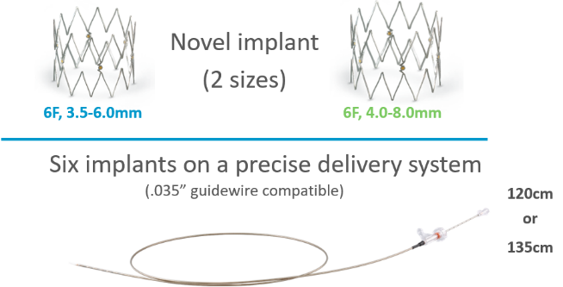 | 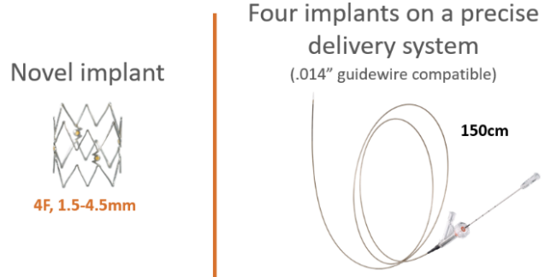

Tack Implant
6F, 3.5-6.0mm |  | 6F, 4.0-8.0mm
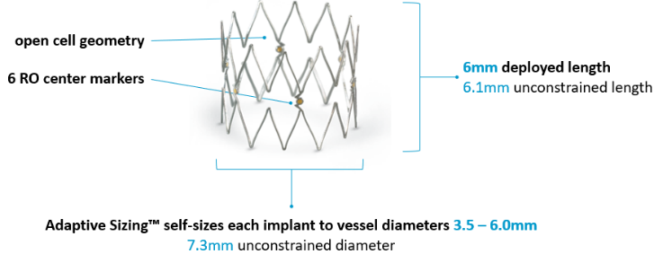 |  | 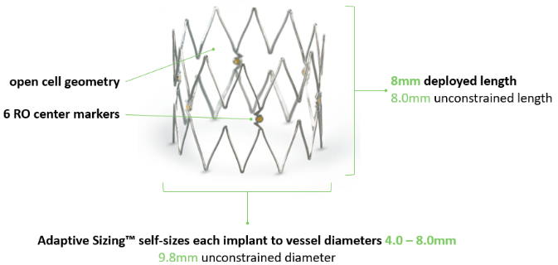
 | 4F, 1.5-4.5mm
 | 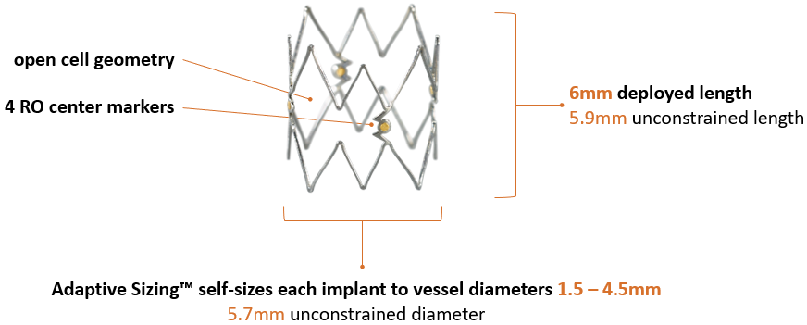

Delivery System
6F, 3.5-6.0mm and 4.0-8.0mm
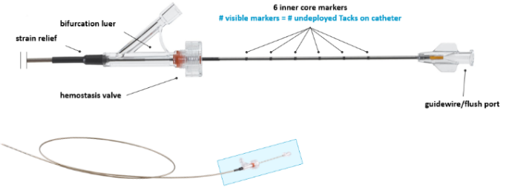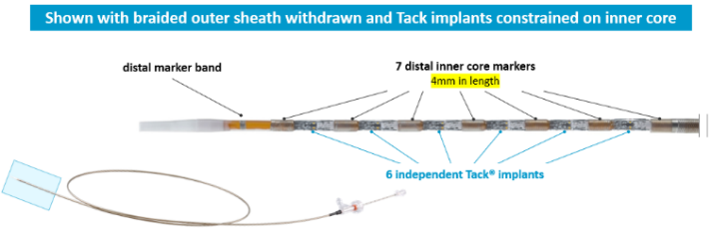
6F, 3.5-6.0mm and 4.0-8.0mm
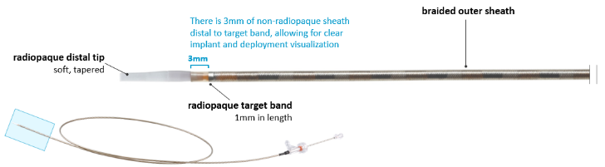
4F, 1.5-4.5mm
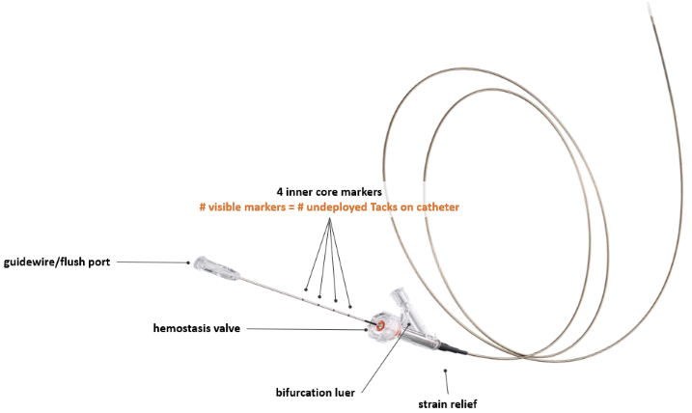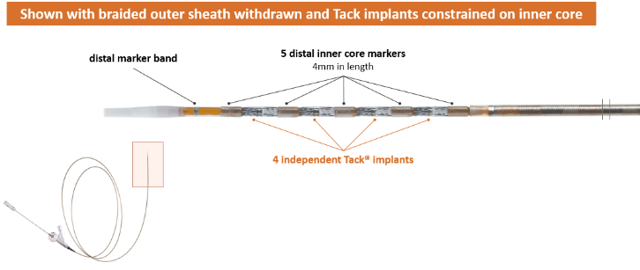

Mark or identify areas to place Tack with physician
- Dry-erase on monitor, ruler, roadmap, dry-erase with IVUS catheter and/or ruler with IVUS catheter, etc.

Deploy 2 Tacks
- 1 regular “as-is” deployment
- 1 “custom-spaced” deployment (demonstrate ability to make slight adjustments to the system, positioning either slightly proximal or slightly distal (“dancing” for second deployment)
- Make appropriate target marks on demo deployment tube)
Demonstrate how to appropriately and completely re-sheath the device. Why is this important?
- Prevents accidental, unwanted deployment of additional Tacks
Identify when Tacks should be placed in the course of treatment in the case.
- We always want to Tack last
- We always want to Tack distal first, then work distal to proximal if more Tacks are needed
  - This is to minimize the chance that we need to cross fresh Tacks with devices to treat distal
Identify how to approach Tack in a dissection.
- Trailing edge, then middle area (if needed), then leading edge
- Work distal to proximal, based on access point
Should Tacks be overlapped?
- No. No benefit is gained in radial force, and the is possible increased risk for restenosis
List the key factors to post dilation.
- Mag up, go slow, and visualize balloon crossing each Tack
- Match balloon to guidewire
- Use a new balloon
- Post dilate with same size balloon as pre-treatment, utilizing same or reduced ATMs pressure
Describe what to do if the balloon looks to be contacting or moving the Tack.
- Stop
- Adjust wire bias
- Adjust balloon (rotation, etc)
- New balloon? Does balloon match guidewire?
- If Tacks look good/physician satisfied and not able to safely cross to post dilate, pass on post dilation
What do we do if Tack fails to resolve dissection and/or physician unsatisfied with result?
- Attempt to re-dilate Tacks if possible
- Attempt to re-dilate Tacks with larger balloon if possible
- Utilize a bail-out stent to address/cover Tack(s) in-question
Walk through the process for a live Tack deployment under fluoro video.
1. Play the Tack Deployment under fluoroscopy video.
2. Identify the following on the video
- Distal marker band
- Target band (on sheath)
- Inner core markers, and how many are seen (3)
- Tacks
- Middle markers of Tacks
3. Talk through deployment on the video
- Pull back of target marker band
- Notes slow technique
- Flowering of Tack (once target band has advanced to the next inner core marker)
- When a Tack is fully deployed, and confirmed as deployed (previous Tack fully deploys once the target marker band is over the next Tack)
4. Click here to view the video answer key.

Practice Grade: ____ Pass: ______ Fail: ______

